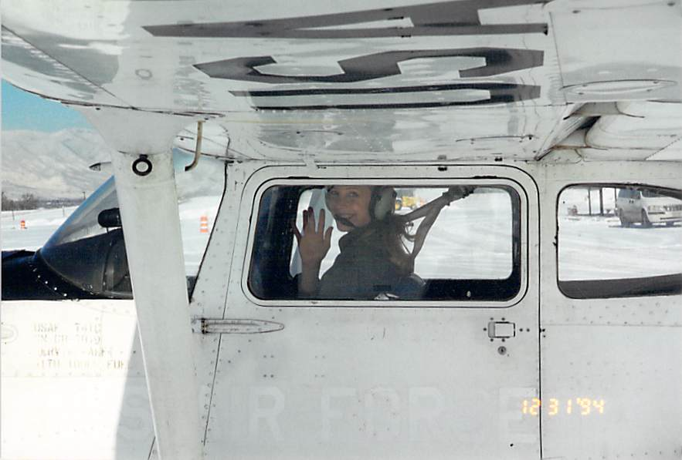Major (separated) Laura Maher, No. 4, Spirit Number 340
By Brye Steeves
509th Bomb Wing Public Affairs
Everyone who pilots the B-2 Stealth Bomber receives a coin with an individual number on it. It signifies the graduation from a six-month grueling combination of classroom academics, exams, simulators and flying.
The number on the coin is not the “Spirit Number,” which tallies anyone who has ever been airborne in a B-2, such as non-pilot government officials, but an even lower digit – one that affirms that they are the newest members of a very small, elite group of aviators.
Today, 14 years after being handed her coin, Laura Maher still carries hers in her wallet. It has a spot next to her class ring from the U.S. Air Force Academy.
“I always wanted to be a pilot,” Maher says, recalling watching her dad fly F-14s for the Navy. “Always. And I always wanted to fly the B-2.”
Maher was the first woman to be assigned the B-2 straight out of the Air Force’s year-long undergraduate pilot training school – an incredibly rare decision at that time for any young pilot.
She had finished near the top of her pilot training class, pretty much guaranteeing her the aircraft of her choice. Maher wanted the B-2, which was almost always assigned to pilots after they were experienced in other airframes.
“Everybody thought it was a joke when they put up a picture of a B-2,” she remembers. “But it was true.”
Maher had proven herself as an aviator and in February of 2005, she became the fourth woman to pilot the B-2.
Her advice to young would-be aviators: “You can do it, too.”

